There are various app of clustering:

One such is ecommerce:

Here they want to group similar customers. Now here by similar they mean purchasing power. That means group customers based on their purchasing power, so they can offer different deals to each type of customer.

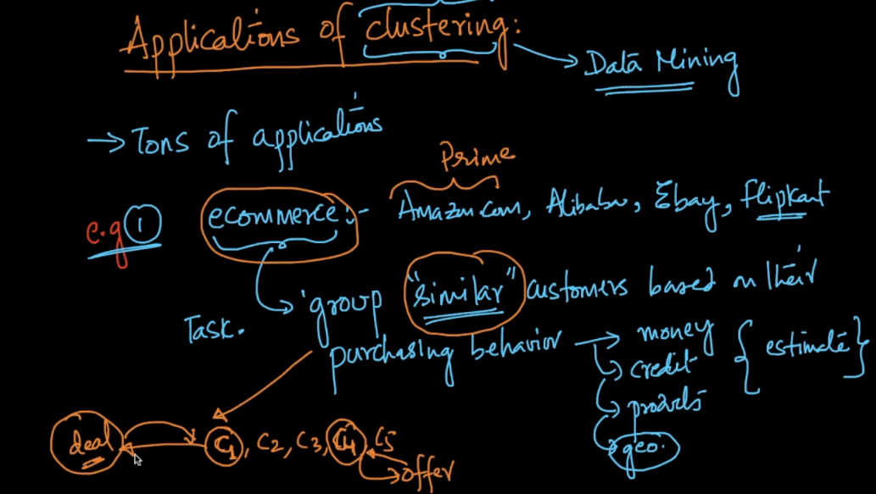

Below there is ex of image segmentation:

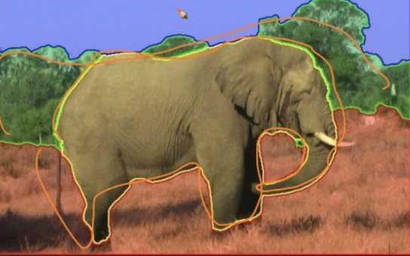

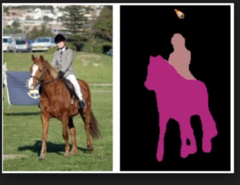

So what is done, group similar things or pixels into regions. Then we can apply ML algorithm to perform detection.

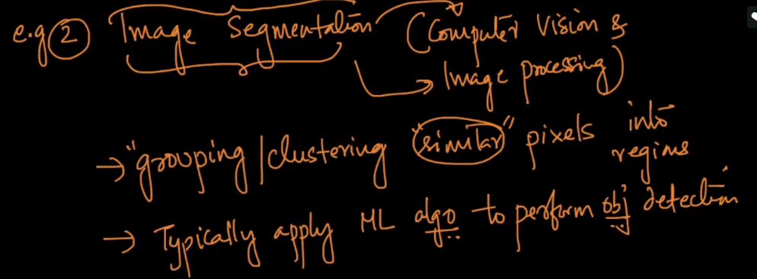

Another ex is amazon fine food review, here how do you thing data is collected to apply ML models on. If it’s done manually to label each review, it would be more expensive in terms of time and cost.

So what we do is make clusters of similar reviews, let’s say we’ve created 10k clusters based on the similarity of words. Now instead of reading all the review, what we do is read only one review from one cluster, if that review is +Ve we will labeled all reviews in that cluster as +Ve, and same with –ve.

